Immutable Ledger….

One cannot change the data inside the block once it is written…

Consider an example:

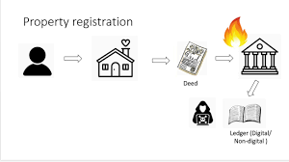

Consider this blockchain

Hash:100

Data

Previous Hash=0

Hash:300

Data

Previous Hash=200

Hash:200

Data

Previous Hash=100

hhhhhh

